Sprint 1 Plan

DnD Assistant App  
4/6/22–4/19/22

Goal: Create a website that allows users to login and roll a dice

User Story:

1. As a player, I want to be able to roll dice with the push of a button so that I don’t need to have physical dice (2+)
   1. Create off canvas and button to feature the Onclick functions (2)
   2. Create the roll functions (1)
2. As a player, I want to be able to log in and out
   1. Task 1: Hook the app up to firebase (1)
   2. Task 2: Create a login and logout button (1)

Team Roles:

* Brian
  + Product Owner, Developer
* Brandon
  + Developer
* Mateo
  + Developer
* David
  + SCRUM Master, Developer
* Cynthia
  + Developer

Initial task assignment:

* Brian
  + Hook up to firebase
  + Navbar
* Brandon
  + Create login and logout
* Mateo
  + Sidebar
  + OffCanvas
  + Home page
* David
  + Roll functions
* Cynthia
  + Buttons

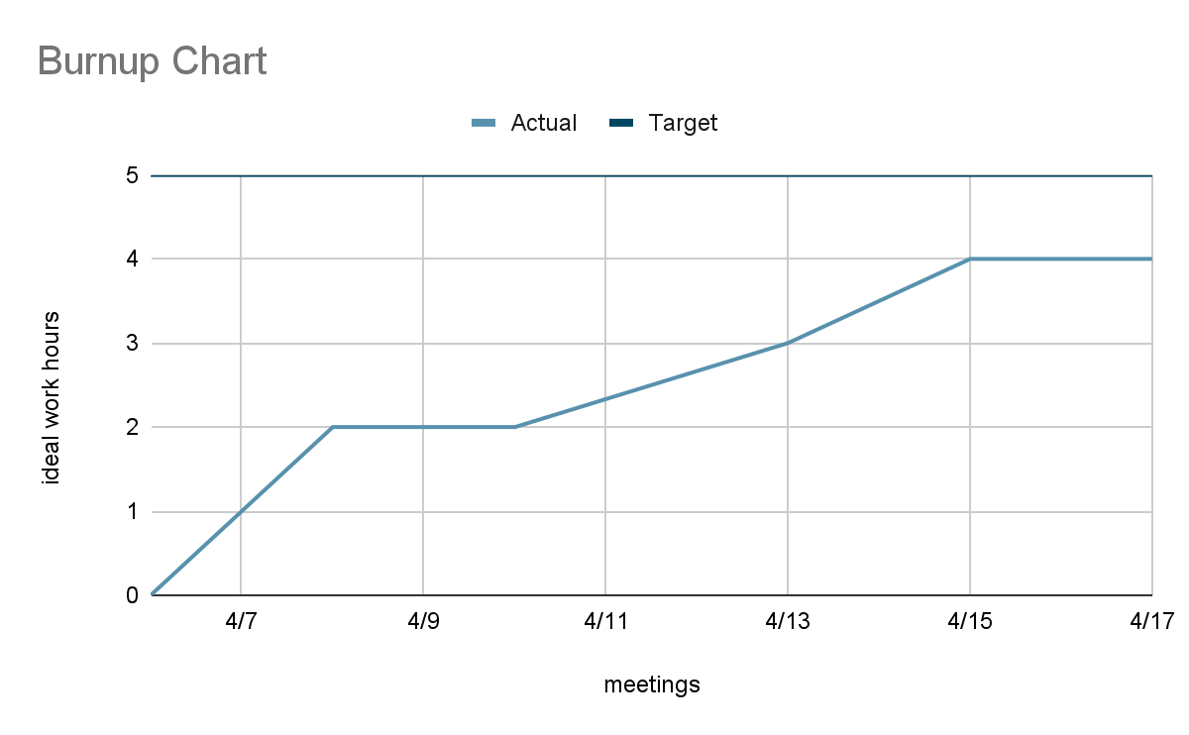

SCRUM board: https://trello.com/invite/dndassistantapp/2ea0443f7a8af527f19901d5f9fc6dc9

SCRUM times:

* Tuesday 9:00 pm
* Thursday 12:30pm
* Friday 4:30 pm (TA)
* Saturday 2:00 pm